Period 8: Document Based Quesetion
Directions: This question is based on the accompanying documents. The documents have been edited for the purpose of this exercise. You are advised to spend 15 minutes reading and planning and 40 minutes writing your answer.
Write your responses on the lined pages that follow the question.
In your response you should do the following:
- State a relevant thesis that directly addresses all parts of the question.
- Support the thesis or a relevant argument with evidence from all, or all but one, of the documents.
- Incorporate analysis of all, or all but one, of the documents into your argument.
- Focus your analysis of each document on at least one of the following: intended audience, purpose, historical context, and/or point of view.
- Support your argument with analysis of historical examples outside the documents.
- Connect historical phenomena relevant to your argument to broader events or processes.
- Synthesize the elements above into a persuasive essay that extends your argument, connects it to a different historical context, or accounts for contradictory evidence on the topic.

Question: Evaluate the causes of the beginning of the Cold War between the US and the USSR from 1945 to 1950.

Documents:

Document 1
Joseph Stalin, February 6, 1945
Prime Minister [Churchill] has said that for Great Britain the question of Poland is a question of honor. For Russia it is not only a question of honor but of security. . . . During the last 30 years, our German enemy has passed through this corridor twice.

Document 2
Gallup Polls conducted in the United States
August 1945
Do you think Russia can be trusted to cooperate with us after the war?
Yes | 54%
No | 3
No opinion | 16
March 1946
Do you think Russia will cooperate with us in world affairs?
Yes | 35%
No | 52
No opinion | 13
July 1946
As you hear and read about Russia these days, do you believe Russia is trying to build herself up to be the ruling power of the world, or is Russia just building up protection against being attacked in another war?
Ruling power | 60%
Protection | 26
No opinion | 14
May 1948
Do you think the United States is too soft or too tough . . . in its policy toward Russia?
Too soft | 69%
Too tough | 6
About right | 14
No opinion | 11

Document 3
George Kennan, State Department official, September 1946
I don’t think that we can influence them [the Soviets] by reasoning with them, by arguing with them, by going to them and saying, “Look here, this is the way things are.” I don’t believe that is possible. . . . If we can keep them maneuvered into a position where it is always hard and unprofitable for them to take action contrary to the principles of the United Nations and to our policies and where there is always an open door and an easy road to collaboration . . . I personally am quite convinced that . . . sooner or later the logic of it will penetrate their government and will force changes there.

Document 4
President Harry Truman, Speech to Joint Session of Congress, March 12, 1947
The peoples of a number of countries of the world have recently had totalitarian regimes forced upon them against their will. The Government of the United States has made frequent protests against coercion and intimidation, in violation of the Yalta agreement, in Poland, Rumania, and Bulgaria. I must also state that in a number of other countries there have been similar developments. . . . At the present moment in world history nearly every nation must choose between alternative ways of life. The choice is too often not a free one. One way of life is based upon the will of the majority, and is distinguished by free institutions, representative government, free elections, guarantees of individual liberty, freedom of speech and religion, and freedom from political oppression. The second way of life is based upon the will of a minority forcibly imposed upon the majority. It relies upon terror and oppression, a controlled press and radio, fixed elections, and the suppression of personal freedoms. I believe that it must be the policy of the United States to support free peoples who are resisting attempted subjugation by armed minorities or by outside pressures.

Document 5
V. M. Molotov, Soviet foreign minister, “The Task of Our Time: Unite Against the Enslavement of the People,” broadcast to the Russian people, November 6, 1947
Today the ruling circles of the United States and Great Britain head one international grouping which has as its aim the consolidation of capitalism and the achievement of the domination of these countries over other peoples. . . . Take, for example, the German question. If in the postwar period America and Britain had adhered to all the principles-let us say, for example, the democratic principles-of the Yalta and Potsdam conferences on the German question, which made possible and fruitful the collaboration of the great allies against Hitlerite Germany, with the aim of liquidating the remnants of fascism, then collaboration between the Soviet Union, the United States, and Britain would also today produce good results. But the United States and Britain have departed from these democratic principles and have violated the decisions jointly taken.

Document 6
David Low cartoon in the London Evening Standard, March 1948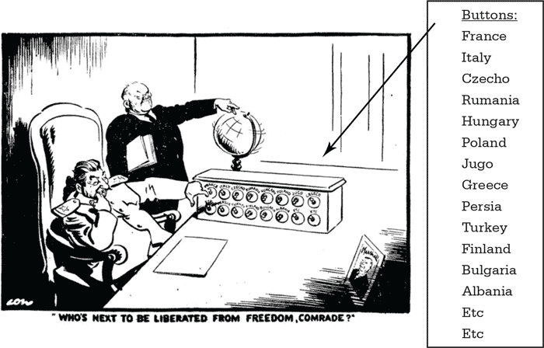

Document 7
Testimony of Whitaker Chambers before the House Committee on Un-American Activities, August 3, 1948
For a number of years I had myself served in . . . an underground organization of the United States Communist Party. . . . Later . . . a member of this group . . . was Alger Hiss, who, as a member of the State Department, later organized the conferences at Dumbarton Oaks, San Francisco, and the United States side of the Yalta Conference. . . . The Communist Party exists for the specific purpose of overthrowing the Government; at the opportune time, by any and all means; and each of its members, by the fact that he is a member, is dedicated to this purpose. . . . Americans [must] recognize at last that they are at grips with a secret, sinister, and enormously powerful force whose tireless purpose is their enslavement.

Student Sample Response:
When World War 2 ended in 1945 it left much of Europe in turmoil and decay. This made many European countries such as Germany, susceptible to communism. Using contextualization, it can be seen that these countries that were in ruins now had to make the choice between communism, the form of government being used by the USSR at the time or capitalism, like the USA. This decision between communism and capitalism created many economic, social and political conflicts, ultimately leading to the Cold War between America and the USSR.
In the years leading up to the Col War, there were many economic problems. Post war European countries were suffering. The idea of communism sounded very pleasent to them. The Soviet Union chose not to participate in the International Bank for Reconstruction and Development, which aimed to restore war-torn Europe. Furthermore, the USSR rejected the Baruch Plan which would have regulated nuclear weapon production.
Additionally, social difficulties between the US and USSR helped contribute to the Cold War. In the yrs leading up to the Cold War, there was a lot of propaganda that influenced many people. Also, the Hiss case made Americans paranoid. They believed there were communist spies in the US government. The USA joined NATO, but refused to let the USSR join. NATO said we would go to war to protect other countries. In response to NATO the USSR created the Warsaw Pact. Overall, there was distrust towards the USSR entirely.
Furthermore, political problems contributed to the Cold War. The USA and USSR had different views on government and the containment vs. expansion of communism. Trumans containment Plan stated that US would not allow communism to spread, while the USSR supported communism, and many communist countries such as Korea and China. The Truman Doctrine and Marshall Plan are more examples containment plans. In 1948, the USSR enacted the Berlin Airlift, cutting off US access to communist Berlin. Furthermore, the USSR did not follow the rules created at the Yalta conference. They did not allow free elections to take place in East Europe, angering the USA.
In the years leading up to the Cold War, there were many economic, social and political disputes causing the spread of communism. These disputes led to the investigation of federal employees in America through the Loyalty Review Board and McCarran Internal Security Act. This also led to the Korean War, where America captured South Korea from communist North Korea, and setup a capitalist society there.

SCORING

Thesis – 1 point available
The essay receives 1 point for thesis. In the introductory paragraph, the student accurately characterizes the causes of the Cold War as a fight between communism and capitalism that manifested itself in economic, social, and political conflicts.

Analysis of documents – 3 points available
The essay receives 0 points for document analysis. There is no attempt to explicitly address the documents nor to extend their analysis. Though some of the topics discussed in the essay are subjects within the documents (Hiss Case, Truman’s containment policy, propaganda that influenced people) they are not explicitly tied to any documents.

Analysis of outside examples to support thesis/argument – 1 point available
This essay receives 1 point for outside information in support of the thesis. Such examples include the rejection of the International Bank for Reconstruction, the Baruch Plan, the Berlin airlift, the failure of the Soviets to uphold their promises for free elections in Eastern Europe at Yalta, and the creation of NATO and the Warsaw Pact.

Contextualization – 1 point available
This essay receives 0 points for contextualization. Although the essay articulates very clearly in paragraph 4 the foundation of the cause of the fight, this is the essence of the question, and is not a connection to another historical phenomena relevant to their argument.

Synthesis – 1 point available
The essay receives 0 points for synthesis. The attempt to finish off the essay with events such as the McCarren Act and the start of the Korean War does not extend the argument to a wholly different historical context, since these events occur at the end of the period of the question.

Score – 2/7

